Why does bodywork and painting cost so much? We break it down

Time is Money

By Barry Kluczyk from the November 2019 issue of Hemmings Muscle Machines
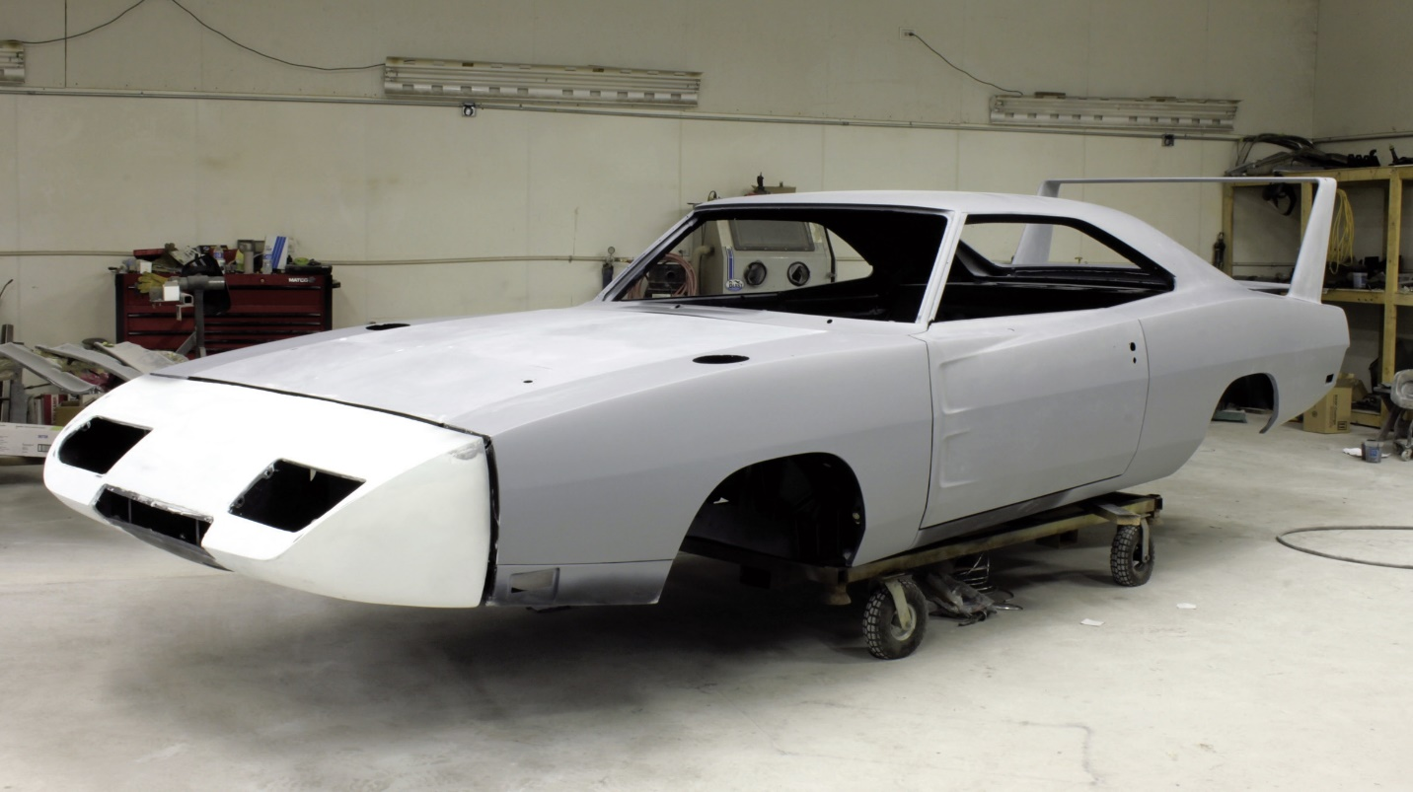

An inside look at the costs of restoration
A friend of ours, Jeff Murphy, dragged his unrestored ’69 Mustang Mach 1 onto a trailer and sent it off to a restoration shop after it languished in his walk-out basement for the better part of 30 years. He was surprised when the estimate for the bodywork and paint elements of the project came this close to $40,000.
At a glance, the dusty, but complete and seemingly solid pony car didn’t need much. Sure, there were some rust bubbles behind the rear wheel openings and the dings and minor dents that come on a 50-year-old car—even if it had spent more than half of its life off the road—but for someone who hadn’t had a muscle car restored before, the bodywork and paint estimate was a shock.
“I didn’t think I was totally naïve about the cost, but it was still an eye-opener,” says Jeff. “I wanted to be realistic with the level of the restoration, because the car didn’t have the original engine and I wasn’t looking to make it a concours winner. I just wanted it to look good. Well, maybe better than just good, but not necessarily a show car.”
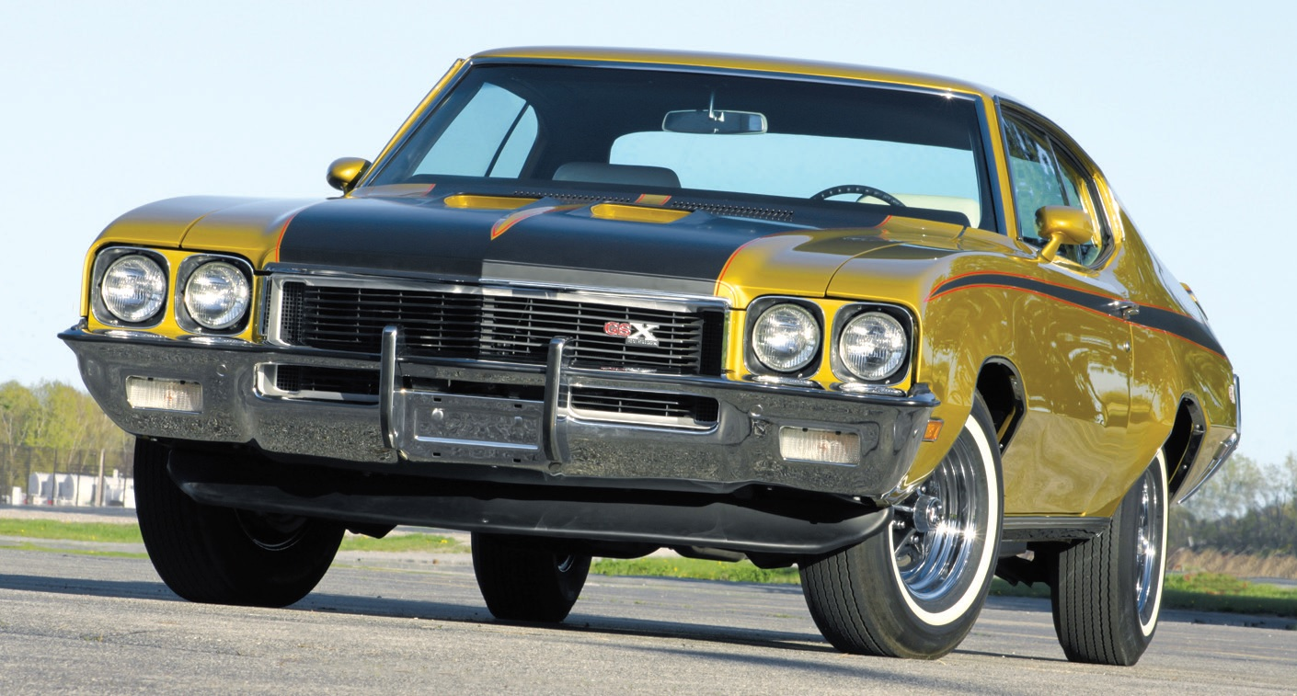
The cost of bodywork and paint is driven almost entirely by time— and the more of it that’s spent on surface prep and color sanding, the better the final result will be.
To be honest, the paint-and-bodywork estimate Jeff received was in line with costs today for a car not being restored to a concours level, where, depending on the amount of bodywork involved, costs could run double, triple, or more. The frustrating thing is, the vast majority of enthusiasts simply don’t have cars restored often, so it’s difficult to gauge estimates and the degree of quality restorers will deliver.
It all boils down to one thing: Time. Most of it comes in the form of prep work, including bodywork to straighten and repair the sheetmetal, block sanding the body before painting, and color sanding it afterward to achieve a deep finish. Laying down the color requires the least amount of time in the project; and, unless you’re taking the car to a splash-and-dash paint shop that may or may not mask off the fender badges, it typically takes hundreds of hours to do correctly.
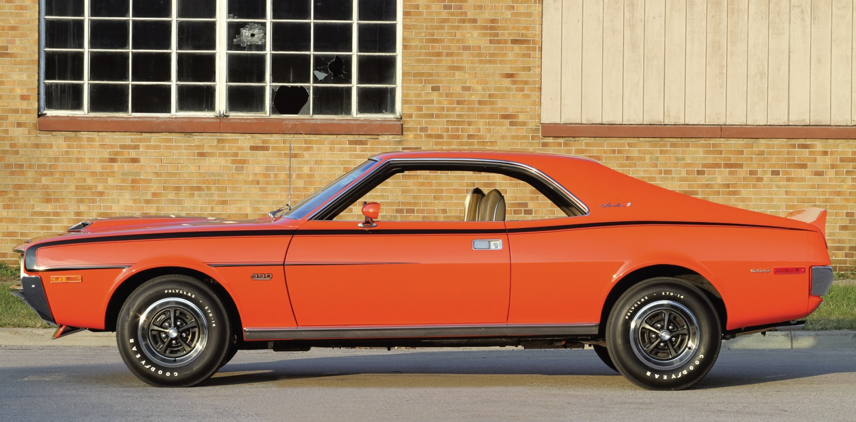
Frustratingly, estimates can vary widely for paintwork, from a few thousand dollars for a comparatively straightforward respray to tens of thousands of dollars for more elaborate jobs involving bodywork and concours-level surface finishing.
Restorer Nyle Wing, whose work has been featured previously in HMM, says that he might have upwards of 400 hours into the body surface prep for his show-winning restorations, with only another eight or so invested in actually spraying the paint. That’s 400 hours of bodywork and block sanding. At a labor rate of, say, $90 an hour, that’s $36,000 before the first drop of paint is applied. The color sanding tacks on even more.
Some of the very best, blue ribbon-gathering restorations often consume 1,000 hours or more in the bodywork, paintwork, and color sanding, though many enthusiasts have had excellent bodywork and paintwork accomplished for far less. Total labor hours in the 400- to 500-hours range is reasonable for a non-concours job, which puts our friend Jeff’s estimate for his Mach 1 right in the ballpark.
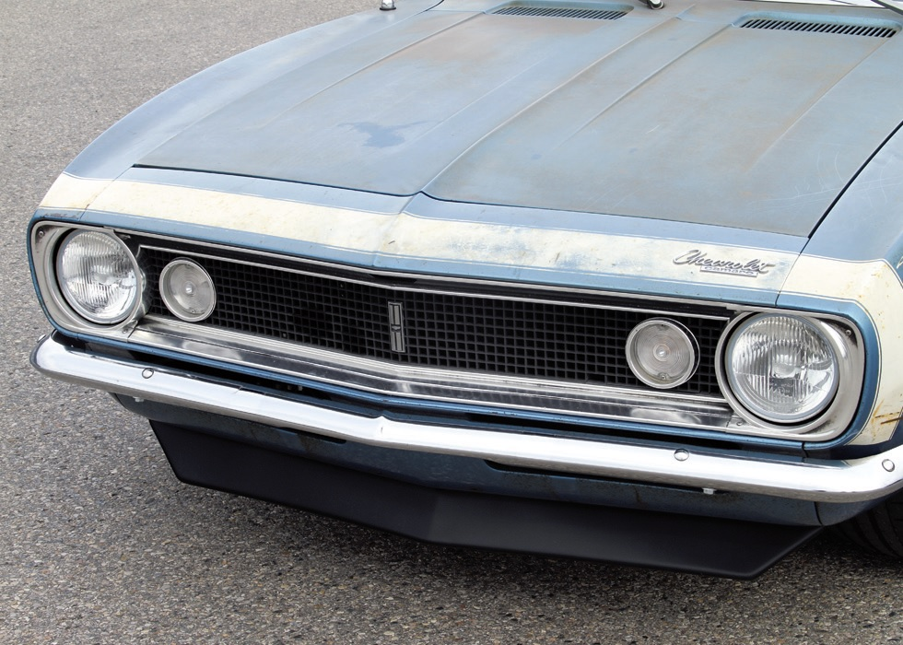
Even on a car that is otherwise seemingly straight, a respray can involve dozens and even hundreds of hours in preparation; and with labor rates of anywhere from $75-$100 per hour, the tally adds up quickly. Even 40 hours of prep work on a car with no other bodywork needs totals $3,600 (at $90/hour). The costs of painting, the paint materials, and follow-up color sanding add more, making it difficult for a good-quality paint job on an otherwise excellent body to cost less than $10,000. Typically, it’s more.
The trade-off, compared to the concours cars, is obviously less time spent on surface prep and color sanding, making it all the more important to understand restorers’ ranges of approaches to their work and discussing what’s right for your own vehicle.
Think of it as a twist on that old adage, “Speed is just a question of money. How fast do you want to go?” But it this case: “Paintwork is just a question of time. How shiny do you want it to be?”
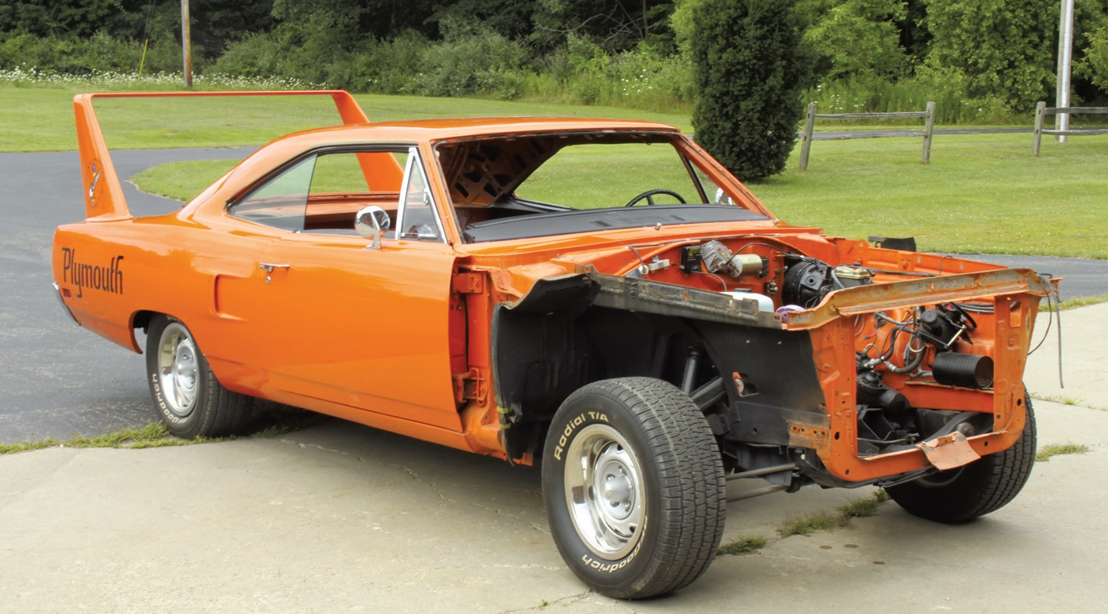
Disassembly is a time-consuming, but necessary procedure, even for a vehicle not undergoing a total, frame-off or rotisserie-style restoration. Owners can save money by doing as much as possible themselves.
ALL-IN INVESTMENT
It doesn’t matter whether it’s a comparatively simple respray or a total frame-off/ rotisserie-type restoration, every bodywork- and-paint project involves several basic steps. We’ve broken down the basics here, with the caveat, of course, that every project differs and the hours involved can vary significantly, as can labor rates, but this offers a primer on what the shop will do with your vehicle and how each step contributes to the cost.
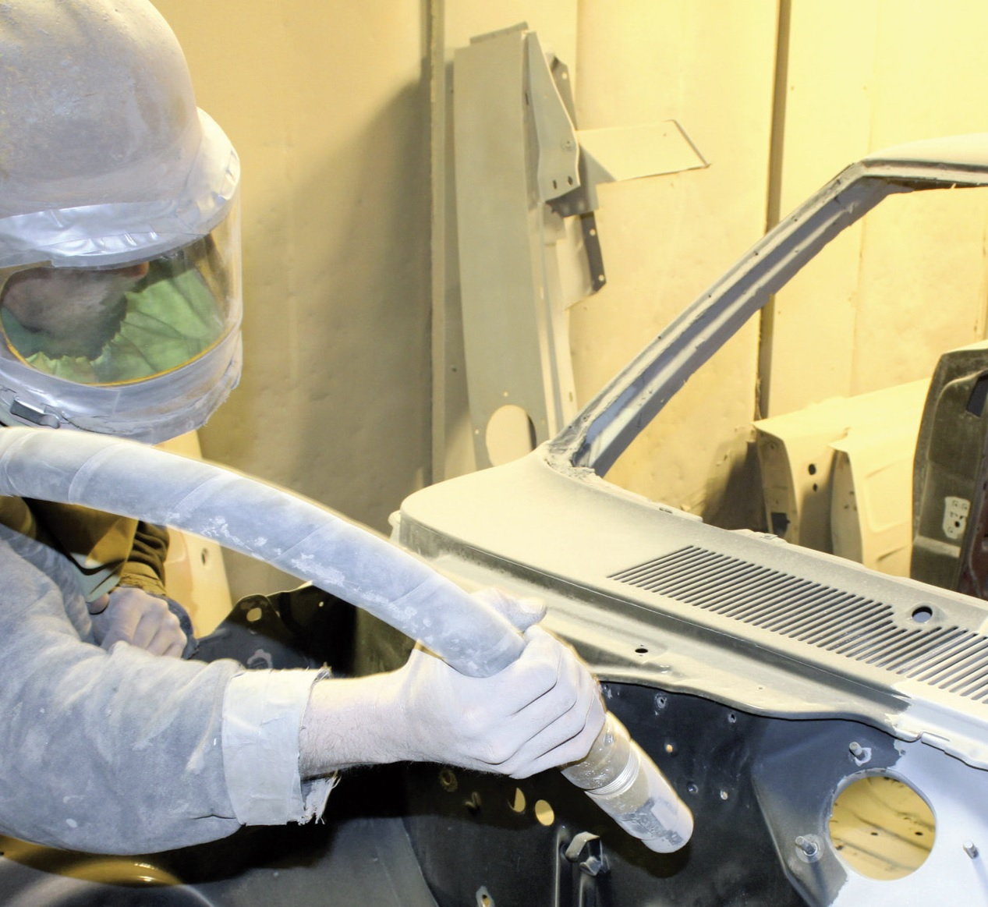
DISASSEMBLY
The vehicle has to be completely disassembled before any restoration work can commence. If left for the restoration shop to do—and some will insist on it for continuity and parts-tracking assurance— it can take 12-20 hours, or more, on a frame-off job, including the time required to bag and tag all the parts that have been removed. It’s less time on a frame-on respray, but time nonetheless. Set aside at least $2,500 for the job, but the more the owner can do himself or herself, the less time the shop will charge. See the May 2016 issue (#153) for the complete disassembly details of a 1968 Hurst/Olds.
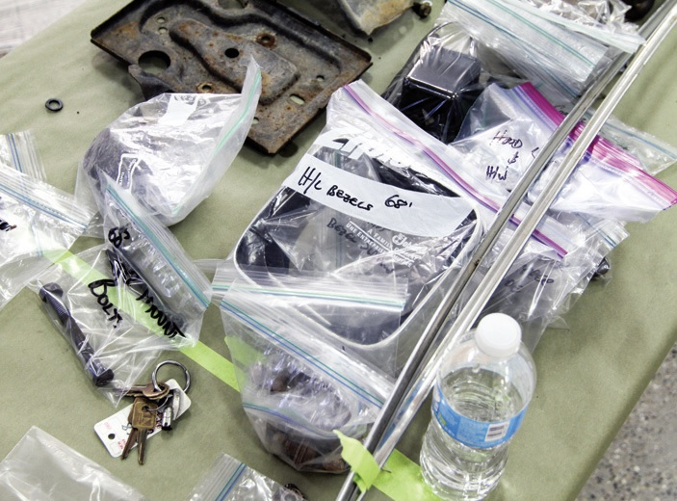
Simply bagging and tagging parts from the car takes time that is included in the hours charged by a restoration shop.
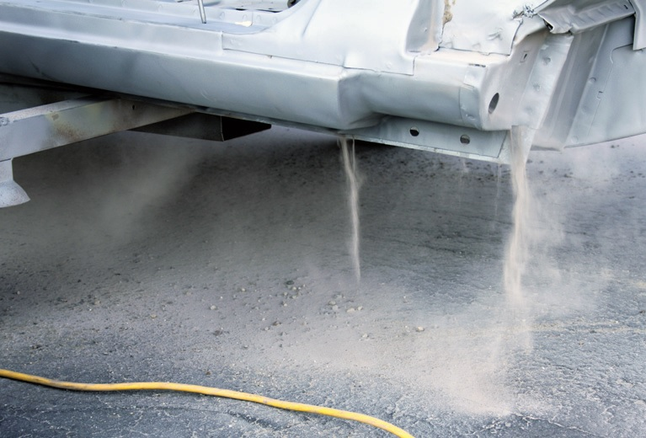
After media blasting, time will inevitably be spent blowing out all the material that settled in the body. Again, it’s all time that contributes to the bottom line.
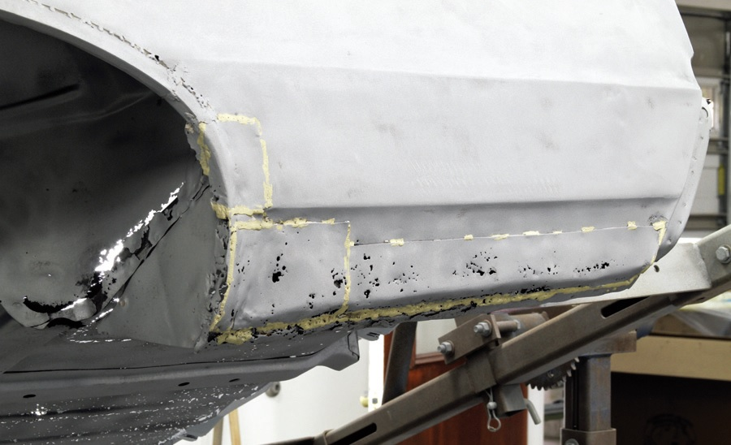
And this is why stripping the body is so important. It reveals the full extent of rust and previous body repairs. This is where the cost of the project can skyrocket, but there’s no getting around it.
STRIPPING
For proper bodywork and paint, the restoration shop will media-blast (or chemically strip) the body, often farming out the job to a professional vendor. It’s the part of the project that will reveal the horrors of 50 years of corrosion and hidden collision repairs. Bank on another $1,500-$2,000 for this job, plus a few more labor hours at the resto shop as they blow out a beach’s worth of media material and apply a quick coat of sealer primer to stave off oxidation of the bare metal. Yes, a body-on re-spray can get by without media blasting, but several hours will still be spent sanding down the existing finish.
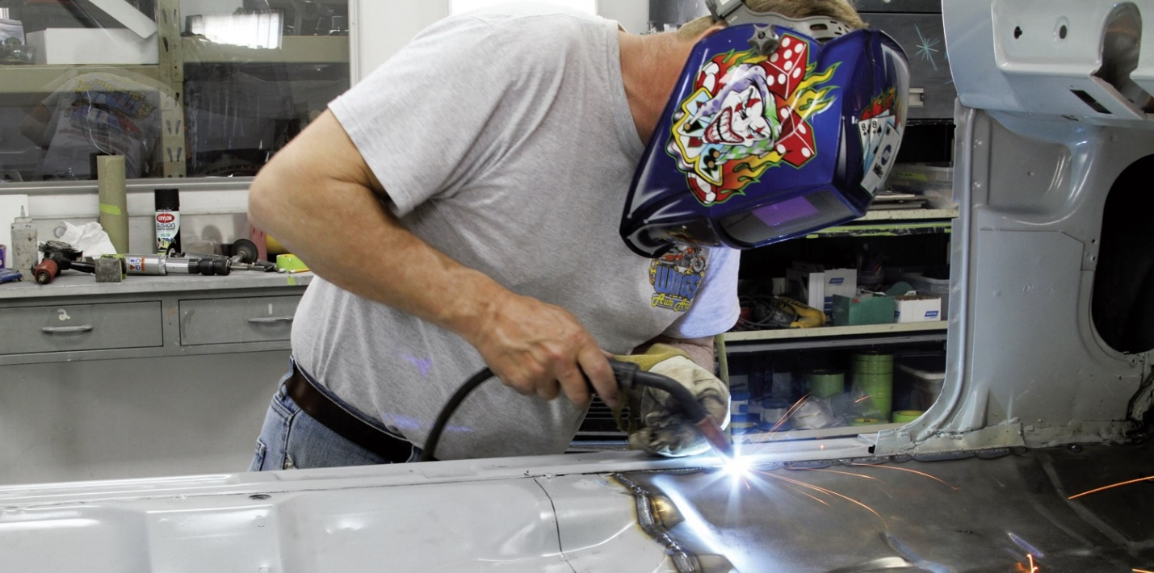
Bodywork is inevitable on almost every project, even those with seemingly no apparent needs. The amount of time obviously depends on the extent of damage and owners should expect the unexpected when the shop peels off the old paint.
BODY REPAIR
This is perhaps the biggest variable, because every vehicle’s needs are different, but it’s safe to say almost every vintage muscle car will have at least some measure of rust or previous accident damage to contend with by the restoration shop. In some cases, it may even be more efficient to do a full panel replacement than repair the existing rust or other damage. Every owner should expect the unexpected, too, when the body returns from the stripper. As such, it’s difficult to assign an estimate on the body work, but it can range from a few dozen hours on an essentially perfect body, to hundreds on a rust bucket. At a labor rate of $90 per hour, a mere 20 hours equals $1,800, while 100 hours of body repair chimes in at $9,000 and 250 hours equals $22,500. It adds up quickly.
PANEL ALIGNMENT
In addition to damage repair, the restoration shop will likely take the time to correct the often-generous tolerances built into vehicles on the assembly line during the ’60s and ’70s. That means adjusting the body panels to achieve more even gaps, while also ensuring the body lines are in much better alignment than when they left the factory. That could add $2,000 or more to the bottom line, depending on the time involved.
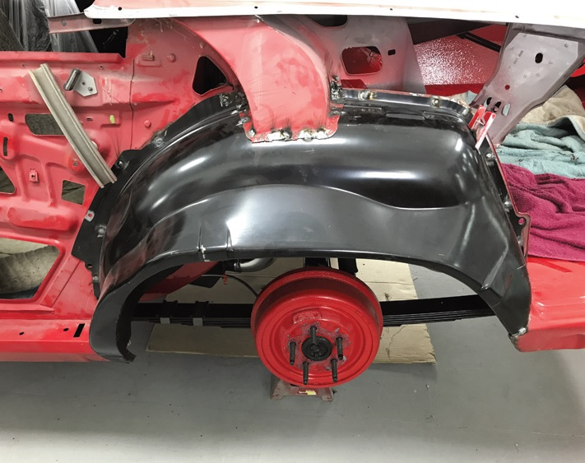
If damage and/or rust is very severe, it is often more efficient and ultimately more economical to replace panels rather than trying to repair them.
BLOCK SANDING
The smoother and straighter the body, the better the paint job will look, and it all comes down to block sanding. Hours and hours and hours of block sanding. Even a reasonable 100 hours of block sanding adds $9,000 to the tally (at $90/hour) — and that’s not for a concours-level finish. Skimping here will affect the quality of the paint job, so make sure the body is as straight as possible. See the December 2016 issue for an in-depth look at what’s involved with block sanding.
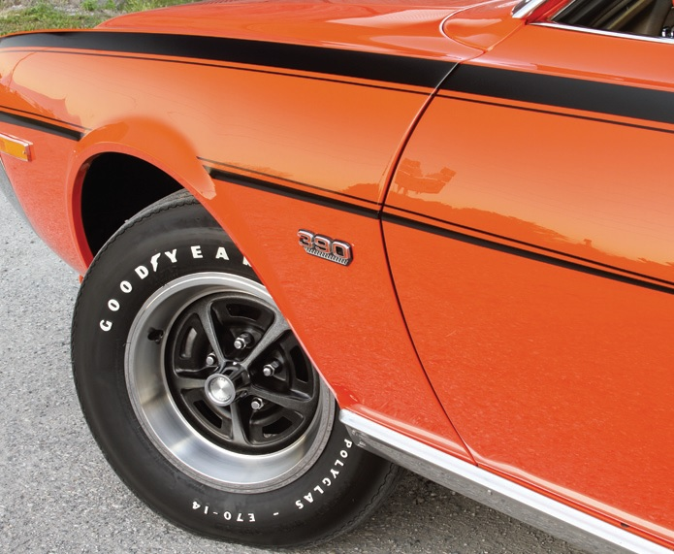
Time spent to properly align the body panels and adjust the gaps between them pays off in the end.
PAINTING
Surprisingly, painting involves some of the fewest hours of the project, as the majority is all in getting the body prepped for the color spray. Depending on how many layers are sprayed, including the clear, this can involve 8-12 hours, totaling $800-$1,200 in labor—but don’t forget the cost of the paint. Two or three gallons of material may be used, costing several hundred dollars or more, per gallon. So, the time in the spray booth and the cost of the paint and supporting materials can total $3,000-$5,000 or more.
COLOR SANDING
Similar to block sanding, a hundred hours or more can easily be spent on the highest levels of color sanding, in order to knock down the orange peel of the paint and achieve a deeper appearance to the finish. Even a comparatively modest 40-50 hours of color sanding adds another $3,600-$4,500 to the final tab.
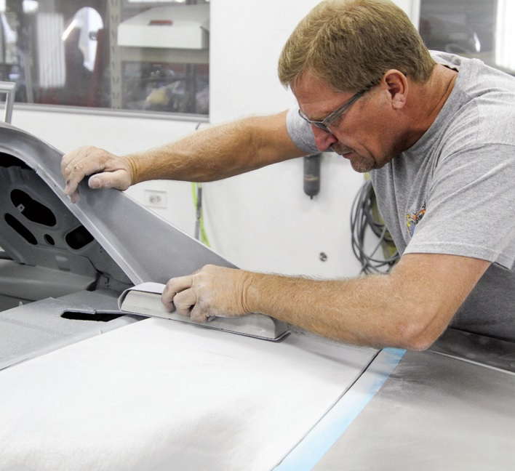
The more time spent block sanding the body, the straighter and smoother it will look when the paint is applied. This is one of the areas that separates a good or even excellent job from a show-winning finish.
SEVEN STEPS
Speaking of color sanding, we asked Detroit-area bodyman and painter Bobby O’Dowd, who is the go-to resource for Roman Sobilo’s After Hours Restorations, what to expect for top-level paintwork. Admittedly, he works at the high end of the business, focusing on cars that contend with the best restorations in the country.
“I use the best materials and don’t cut any corners when it comes to the final paint finish,” says Bobby. “It is a painstaking process that can take hundreds of hours to achieve a completely flat, deep, and mirror-like finish. It’s the only level of work I do, so customers have to understand that when they bring their car to me or Roman.”
Bobby says he uses a seven-step color-sanding process that can soak up 8-12 hours per body panel to arrive at that mirror finish. That can consume perhaps 140 hours after the paint has been applied. At our $90/hour rate, that’s $12,000, or more, added to the project’s final cost.
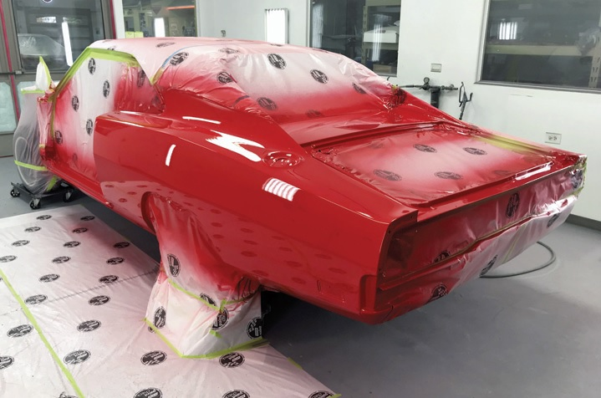
Spraying color is actually one of the least time-consuming aspects of the project. Cost of the paint itself can vary widely, too, making it important to discuss options with the painter.
“We start with 600-grit sandpaper and work up to 5000 grit, before polishing,” he says. “If you want every trace of orange peel removed, it’s the only way to go—and it can take a lot of time from someone with a great eye for detail.”
As for the material costs, they add up, too. Bobby uses Axalta Chromapremier in a basecoat/clearcoat process; and, because he’s sanding so much of the clear to achieve that flat appearance, he applies up to five coats, which can add up to around $2,500.
“It’s not cheap, but the quality is the best, and, with the UV protection built into it, the paint job will look great for years and years,” says Bobby. “All told, there might be $6,000-$7,000 just in the materials cost, but that’s the level of work we’re committed to.”
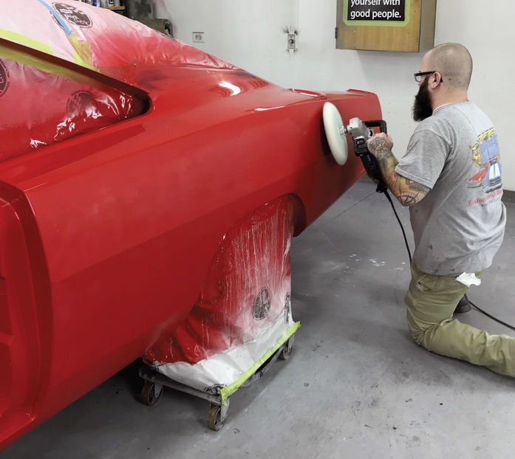
After the paint and clear are applied, color sanding knocks down the orange peel of the finish to give the paintwork a smoother, deeper finish. It is very time-consuming and can add thousands to the overall price of the project.
Realistically, excellent results can be achieved without chasing his show-car-level paint finish, but expectations need to be managed. It’s important to ask a shop how far they take their best paint jobs, whether they’re willing to do something less to meet your budget, and, if so, what would that level of work include. Additionally, there are plenty of excellent paint materials out there that cost significantly less than the materials Bobby uses, which can save perhaps a few thousand dollars—but make no mistake: Automotive paint is not inexpensive.
“With bodywork and paint, you get what you pay for,” says Roman Sobilo at After Hours Restorations. “With Bobby, we focus on the very best, but it can be a difficult conversation to have with customers who haven’t done much homework. Their expectations and the restorers’ often vary, so it’s very important to have a very frank discussion about it.”
Again: It’s all a question of time. How shiny do you want your paint finish?
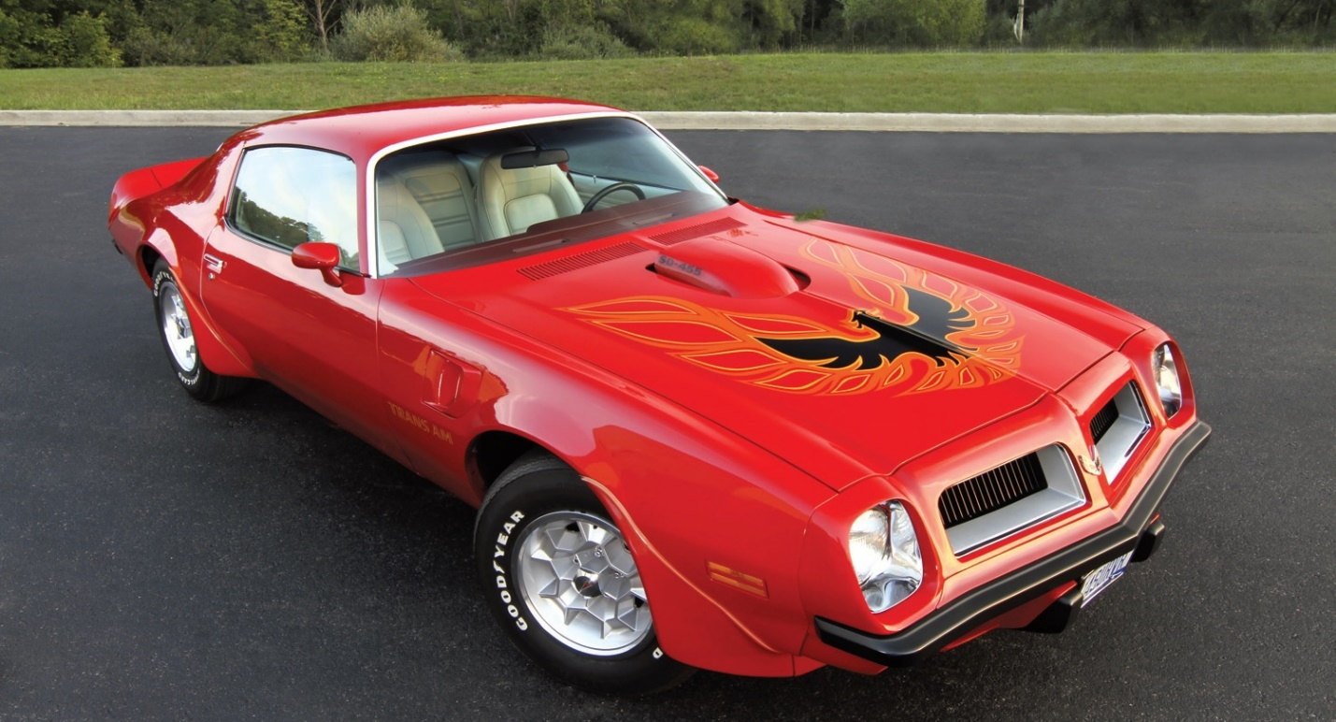
Nothing looks better than quality paintwork done correctly, but achieving the look takes time—and time is money.
“Nobody wants to spend more than they have to, but you’ll be disappointed when you spend tens of thousands of dollars for a paint job that ends up looking only good and not great,” says Roman. “Spending the hours on the preparation makes all the difference and that’s the important thing to understand.”
The bottom line is high-quality paint jobs and the supporting bodywork can be had for much less than the cost of a concours-level restoration, but time is the factor in all projects. Understanding how much of it to commit to your project will give you a better idea of what the bodywork and paintwork will cost.
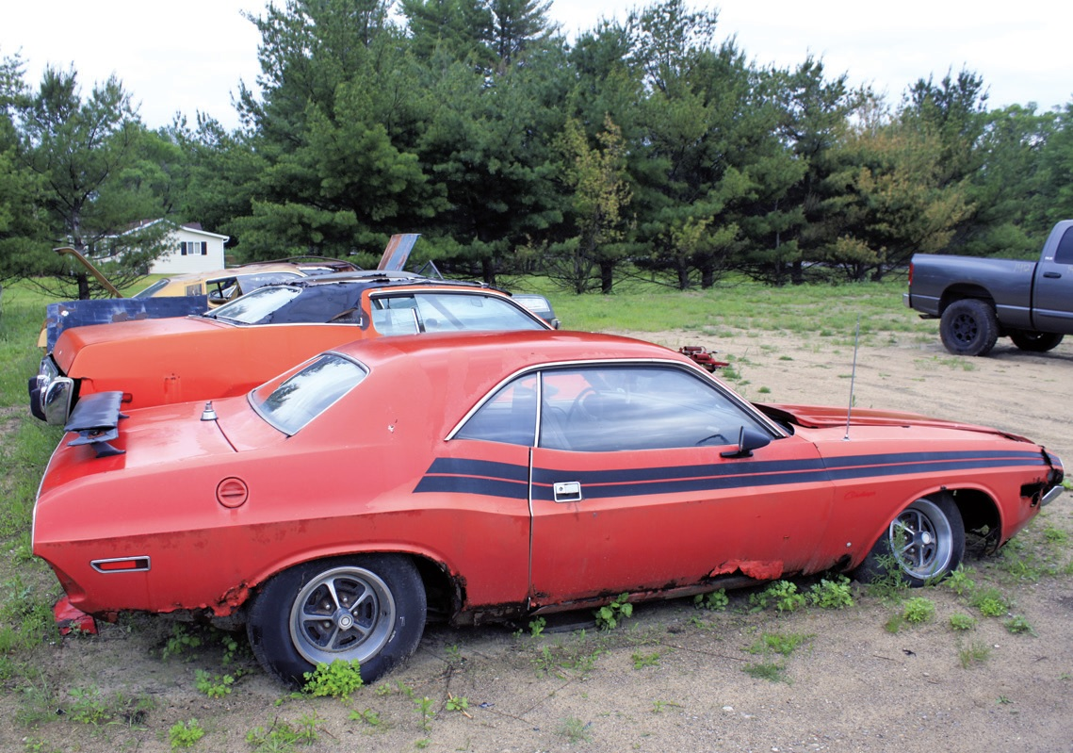
Rust never sleeps. And neither will the resto shop with a project car this badly corroded.
GOOD MONEY AFTER BAD: FIVE WAYS TO BALLOON YOUR RESTO COSTS
We’ve all made mistakes and we’ve all spent money that we know swirled down the drain like the hair you used to have in high school. A restoration represents a huge investment and it’s all too easy to burn cash needlessly. Here are five easy ways to overheat your checkbook:
1. Choose the resto shop by price alone
On a 1,000-hour restoration, there’s a $10,000 difference between a $60-per-hour labor rate and a $70-per-hour rate. That’s not chump change, but it should not be the determining factor for selecting a restorer. Do your homework to make sure the shop does the caliber of work you want and that your car won’t languish in the back corner for five years. Even if you pay a little more in the long run, the satisfaction of a restoration done right is worth it.
2. Let a collision shop do the job
Restoration shops aren’t always easy to find locally and many of the best typically have long waiting lists, so it’s tempting to have a collision shop handle the bodywork and paint. Unless someone in the shop specializes in resto work, don’t do it. Collision shops may be great at pulling out dents and matching factory paint after a fender-bender, but they’re not likely to spend 200 hours block sanding your car. You’ll end up disappointed with the results and waste money by starting over at a true resto shop.
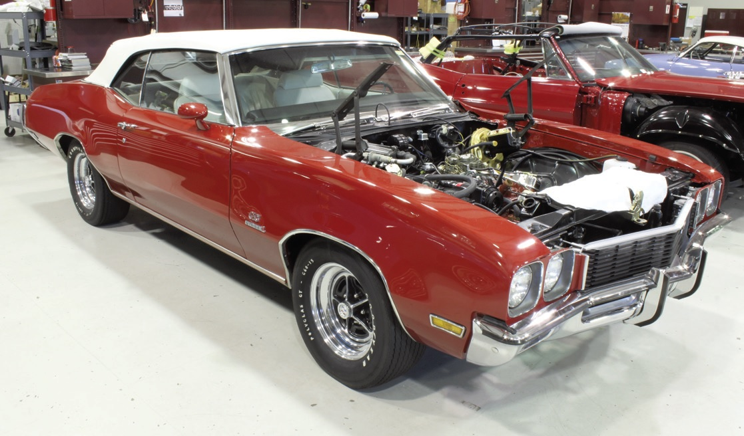
There’s more to bodywork and painting than the cost. Don’t make it the overriding factor when choosing a shop.
3. Start with a total rust bucket
There’s an undeniable emotional connection with cars, but unless you’re starting with your long-lost Super Bee that was just pulled from a farmer’s field, be realistic about your project car’s needs. Serious rust issues require serious labor, so you’re better off spending a few thousand more for a better-condition project car. You’ll save more in the long run.
4. Insist on a color change
If you’re not doing a frame-off/rotisserie-type restoration, where every nut and bolt is removed during disassembly, think long and hard about changing the color of the car. Doing it properly involves more than simply painting the door jambs; and in the case of many Mopars and Fords, it includes the engine compartment. Sticking with the original color, even if it’s not your favorite, is much cheaper.
5. Change course midstream
If you originally sent your car in for a simple respray, but later decide on the frame-off restoration, you’ll be able to feel the heat from your redlined credit card through your wallet. The shop will have to backtrack their work, often duplicating much of it because of your indecisiveness. The hours will rack up exponentially, so make your decision up front and stick with it.

